#M042129
Complement C3 Antibody

Order 021-34695924 orders@ab-mart.com
Support 400-6123-828
support1@ab-mart.com Web www.abmart.cn

50ul
100 uL
√
√

Description:
C3 plays a central role in the activation of the complement system. Its processing by C3 convertase is the central reaction in both classical and alternative complement pathways. After activation C3b can bind covalently, via its reactive thioester, to cell surface carbohydrates or immune aggregates.Derived from proteolytic degradation of complement C3, C3a anaphylatoxin is a mediator of local inflammatory process. In chronic inflammation, acts as a chemoattractant for neutrophils (By similarity). It induces the contraction of smooth muscle, increases vascular permeability and causes histamine release from mast cells and basophilic leukocytes.Acts as a chemoattractant for neutrophils in chronic inflammation.adipogenic hormone that stimulates triglyceride (TG) synthesis and glucose transport in adipocytes, regulating fat storage and playing a role in postprandial TG clearance. Appears to stimulate TG synthesis via activation of the PLC, MAPK and AKT signaling pathways. Ligand for C5AR2. Promotes the phosphorylation, ARRB2-mediated internalization and recycling of C5AR2.
Uniprot: P01024
Alternative Names：
acylation-stimulating protein cleavage product; AHUS5; ARMD9; ASP; C3 and PZP-like alpha-2-macroglobulin domain-containing protein 1; C3; c3 complement; C3a anaphylatoxin; C3a; C3b; CO3_HUMAN; Complement C3; Complement C3c alpha' chain fragment 2; Complement C3c; Complement component 3; Complement component C3; Complement component C3a; Complement component C3b; Complement factor 3; CPAMD1; Prepro C3;
Specificity: C3 Antibody detects endogenous levels of total C3 and C3 beta chain.
Reactivity: Human, Mouse, Rat, Monkey
Source: Mouse
Mol.Wt.: 187 kDa(total), 72 kDa(beta chain)
Storage Condition: Store at -20 °C. Stable for 12 months from date of receipt.

Application: WB 1:1000-1:2000；IHC/IF 1:50-1:500
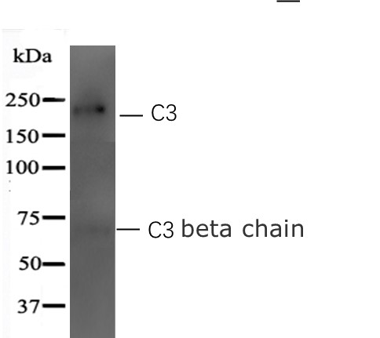

Western blot analysis of extracts from NIH-3T3 whole lysates, using C3 Antibody.

其他推荐产品
#M20001 His-Tag (2A8) Mouse mAb
#M20002 Myc-Tag (19C2) Mouse mAb
#M20003 HA-Tag (26D11) Mouse mAb
#M20004 GFP-Tag (7G9) Mouse mAb
#M20007 GST-Tag (12G8) Mouse mAb
#M20008 DYDDDDDK-Tag (3B9) Mouse mAb (Binds to same epitope as Sigma’s Anti-FLAG M2 Antibody)
#M20012 Anti-Myc-Tag Mouse mAb (Agarose Conjugated)
#M20013 Anti-HA-Tag Mouse mAb (Agarose Conjugated)
#M20018 Anti-DYKDDDDK-Tag Mouse Antibody (Agarose Conjugated) (Same as Sigma’s Anti-FLAG M2)
#M20118 Anti-DYKDDDDK-Tag Mouse Antibody (Magnetic Beads) (Same as Sigma’s Anti-FLAG M2)

